Release Build Procedures
Revised 5/19/06

- Finalize Build Notes on Wiki, and ask team members to review

- Freeze VSS

- Do complete “get” of Tawala source code into an empty folder. (Some day I expect to have a dedicated “build” machine.)

- Build TawalaTest solution and run nUnit test suite

- Open Tawala solution

- Set configuration to Release

- Check out Setup.vdproj and config.xml under the Setup project in Source Safe

- Select the Setup project in the Tawala solution and:
  - Set the Version property (least significant digit) in the Properties window to the proper Build number); answer “Yes” when prompted about changing ProductCode
  - Update the Description property to reflect the Build number

- In config.xml update the build attribute to reflect the Build number

- Check in Setup.vdproj and config.xml

- Build entire solution, including Setup project

- Zip setup files (Setup.exe and Tawala.msi) into Tawala.zip.

- Run WinZip Self-Extractor wizard to produce executable installer.
  - Input = Tawala.zip
  - Take all default options except: Be sure to check the “Unzip automatically” option at the end of the wizard. After you click next you’ll see a warning about “some sysops refuse to accept files.” Click “Yes” to Continue anyway.
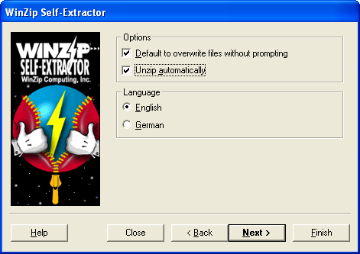

- Test the resultant installer

- Test the installed app itself. Exercise it thoroughly, because stuff that was working before can be broken now!

- Update the Iteration Builds Wiki page: http://www.jdftech.com/FlexWiki/default.aspx/MyWiki.IterationBuilds
to show the new build number and date, and to reference the Build Notes for the new build.

- Create a new Build Notes page for next week’s build, and fix up the link on the Iteration Builds page to reference it.

- Copy the version numbers for Designer.exe and all the DLLs into the Build Notes page

- Copy the installation file to the jdftech dev server for downloads via the Wiki:
  - C:\Inetpup\wwwroot\Docs\ Builds\....
(Note: the above folder is available via FTP as “Builds” at the root level)

- Update the Build Notes page to point at the proper location for the Wiki download.

- Label the entire VSS project (at the root $ level):
  - Label = “Alpha num - Build num” (e.g., Alpha 1 - Build 4)
  - Details = “Alpha num - Build num – date” (e.g., Alpha 1 - Build 4 - 4/8/05)

- Unfreeze VSS.

- Contact Tony as to how to post it on the Web site.

- Send out distribution message to: staff@tawala.com (Doug, Steve, Kevin, John, William and Tony).

